## Phylogenetic Tree of Aligned Sequences

1. Non-Redundant Database-

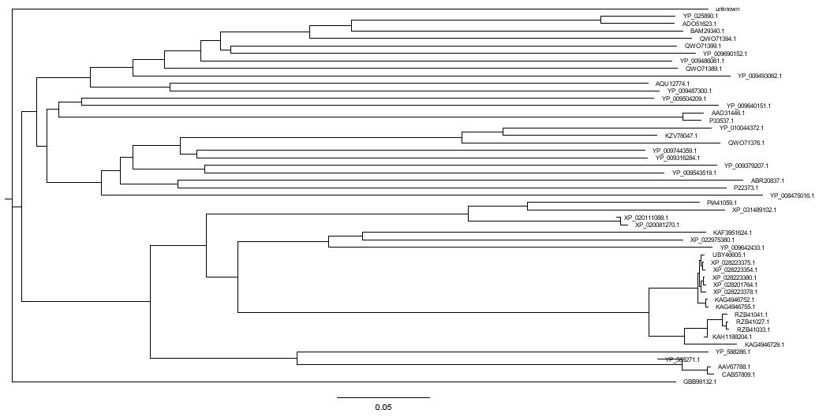

2) RefSeq Select Protein Database

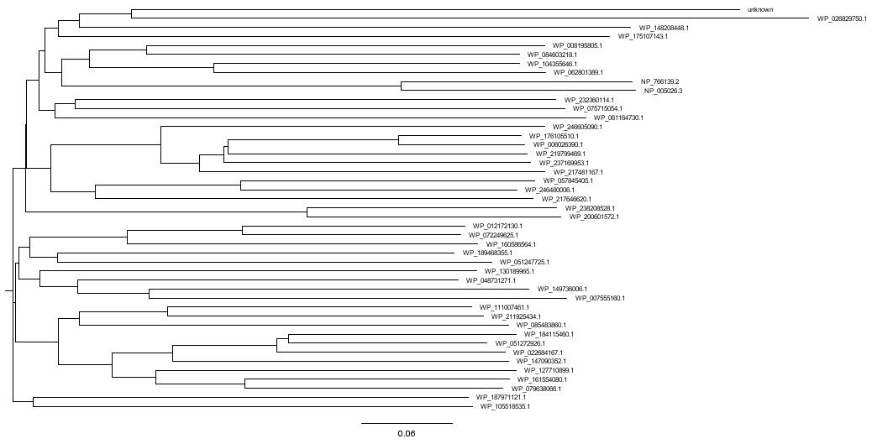

3) Reference Proteins Database

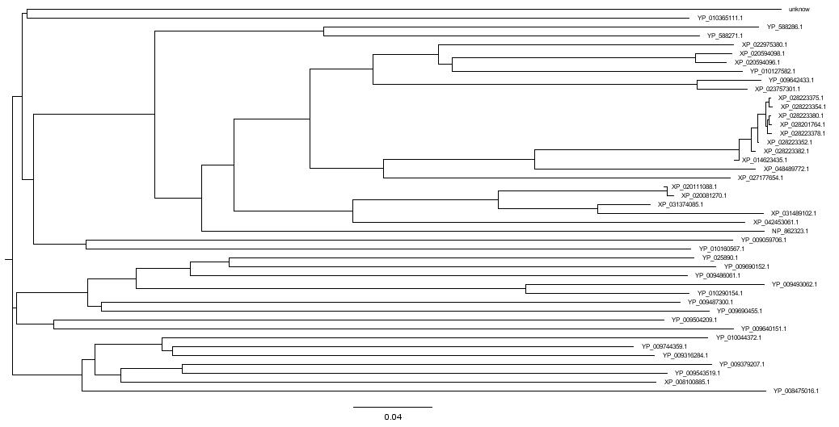

4) Model Landmark Database

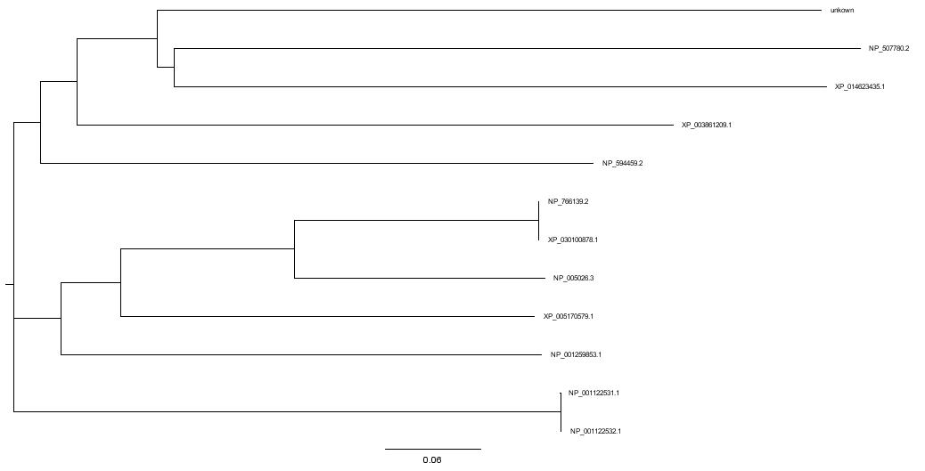

5) Swiss Prot Database-

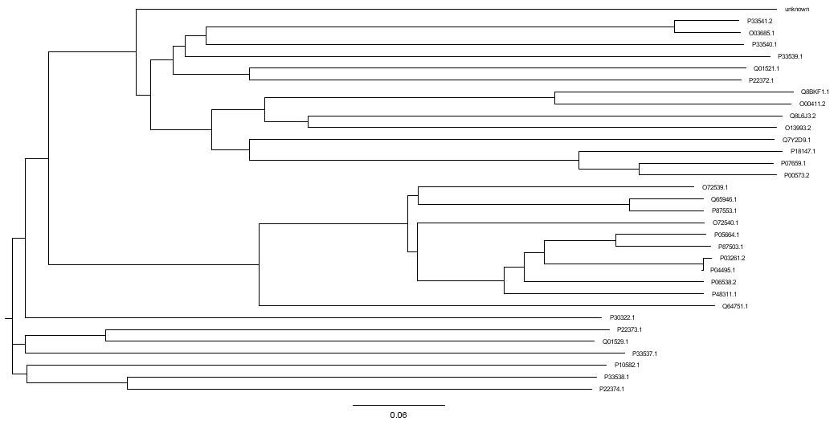

6) Patent Database-

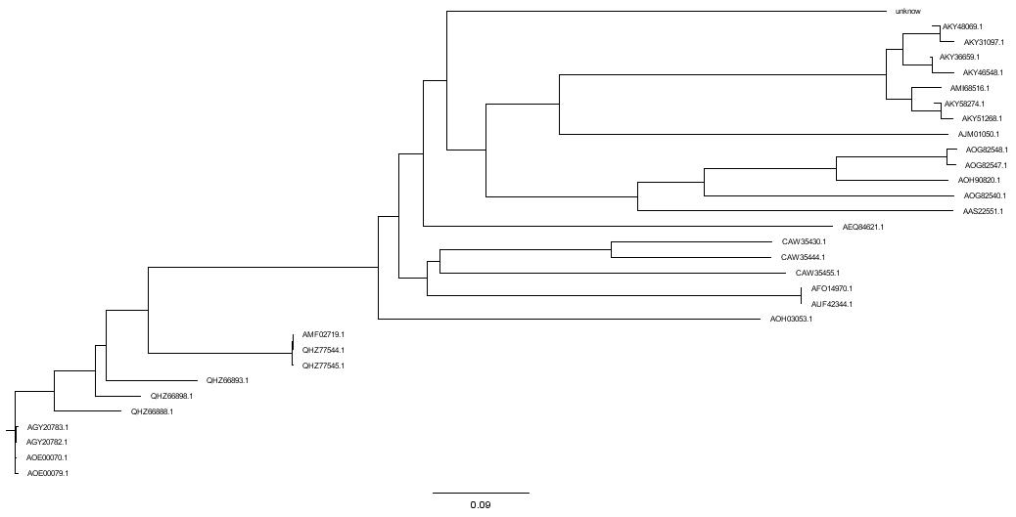

7) Protein Data Bank-

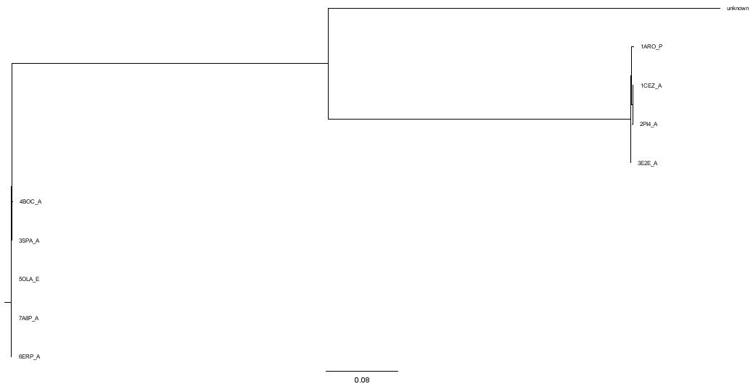

8) Transcriptome Shotgun Assembly Database-

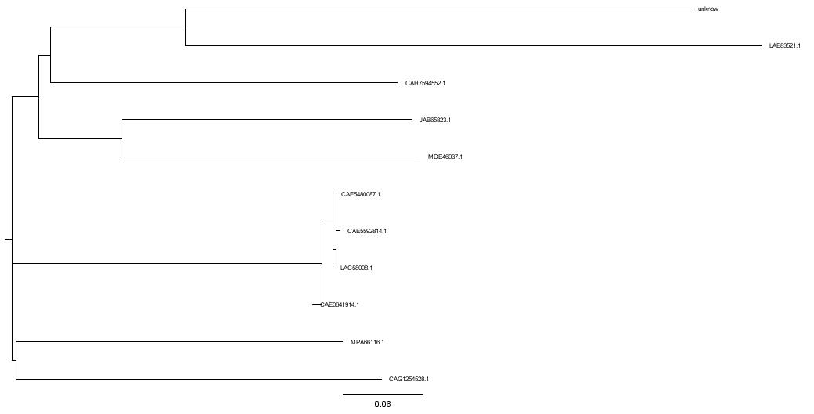

tBLASTn

1. Nucleotideide Collections Database

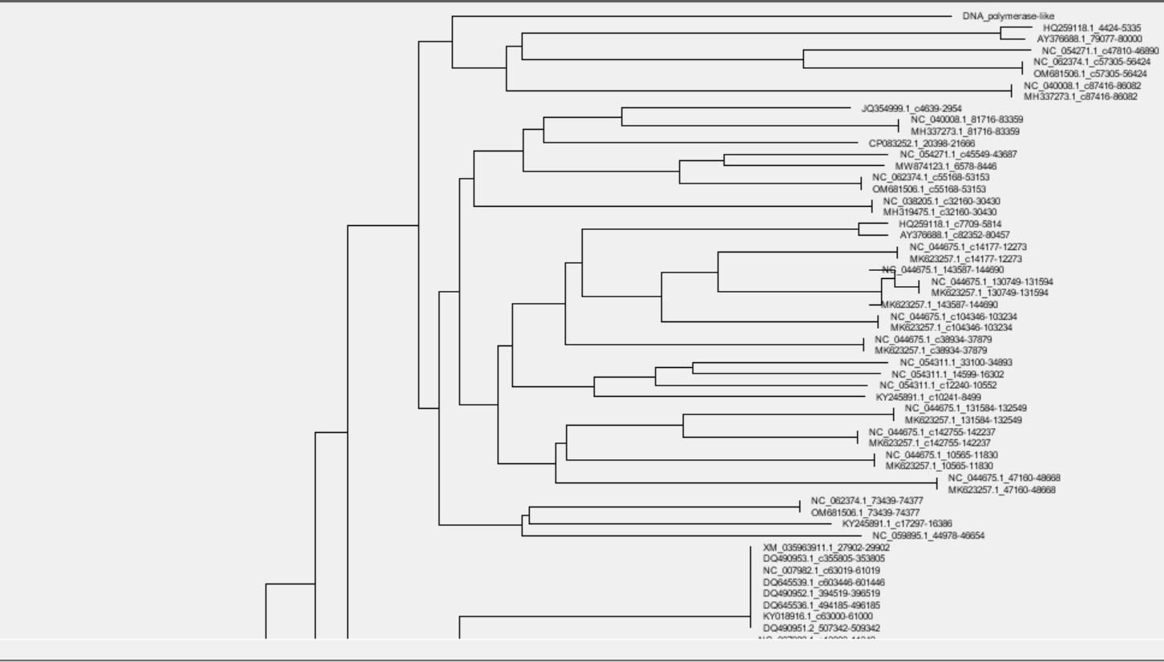

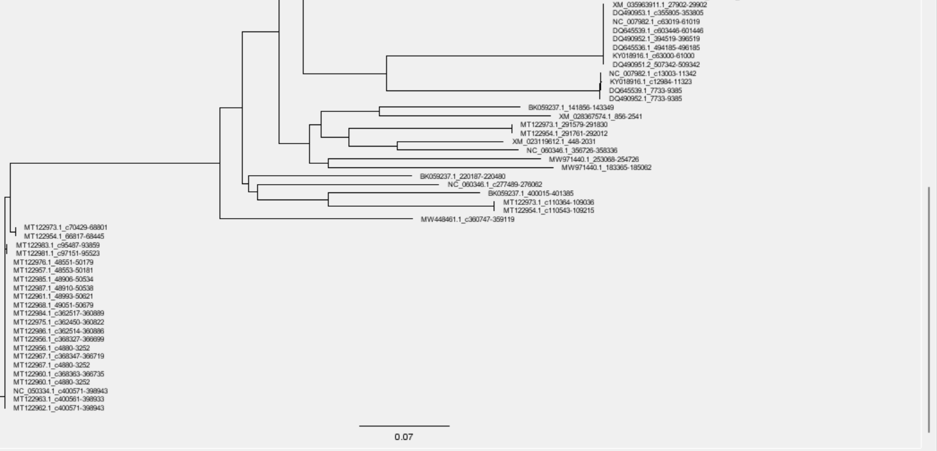

1. Refseq_select_rna  database-

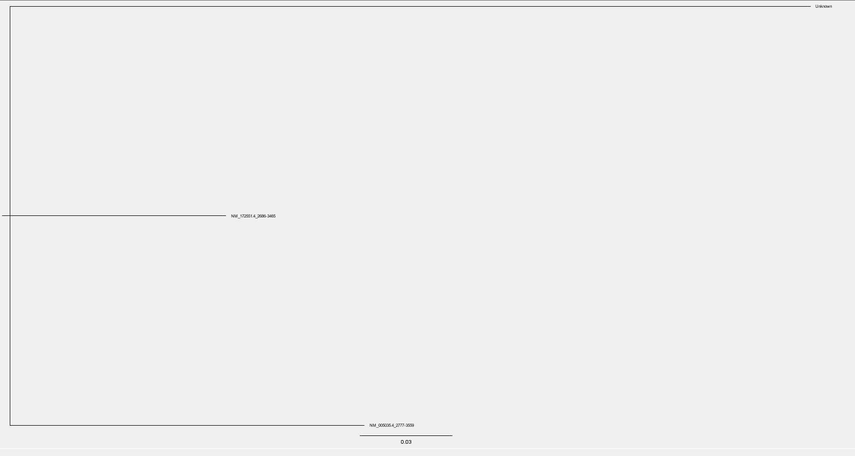

1. Refseq_rna database-

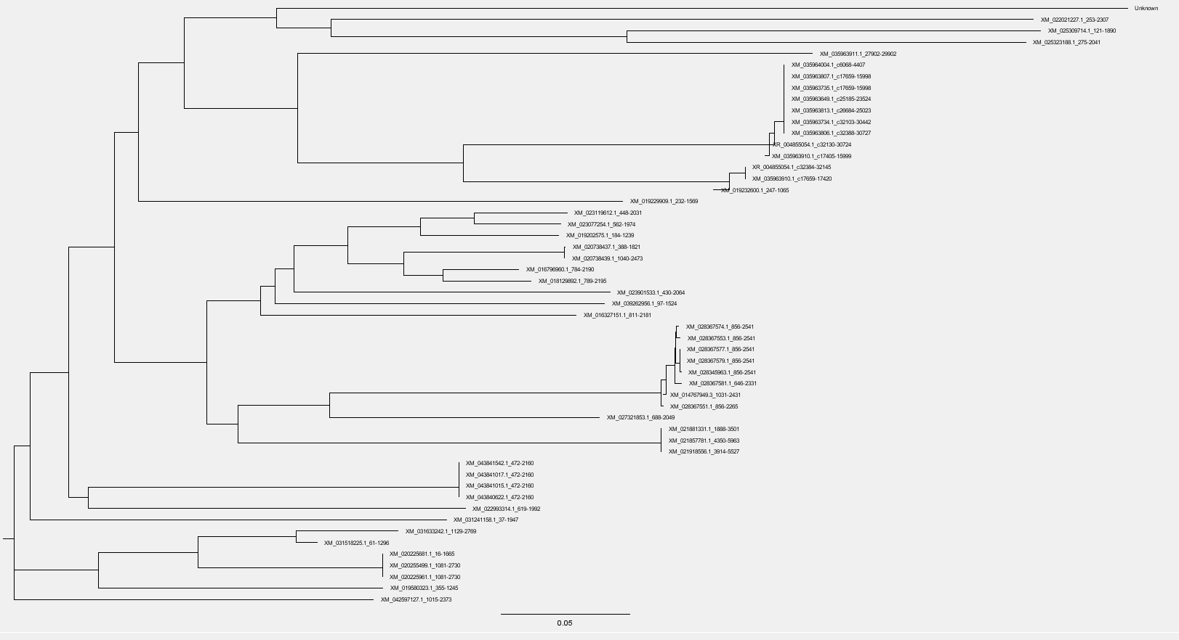

1. Refseq_representative_genomes

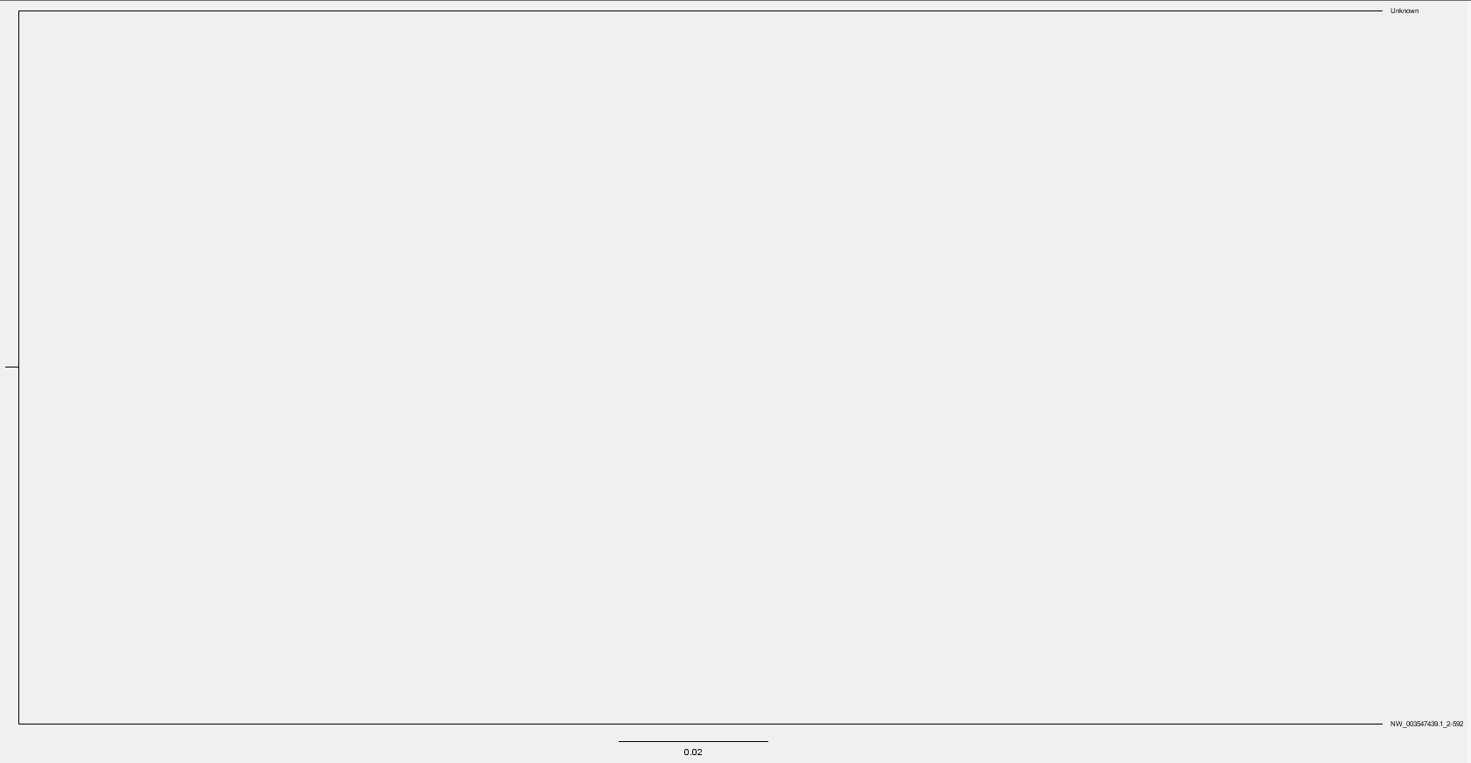

Same Observation with RefSeq Genome and Whole Genome Database

1. Expressed Sequence Tags Database-

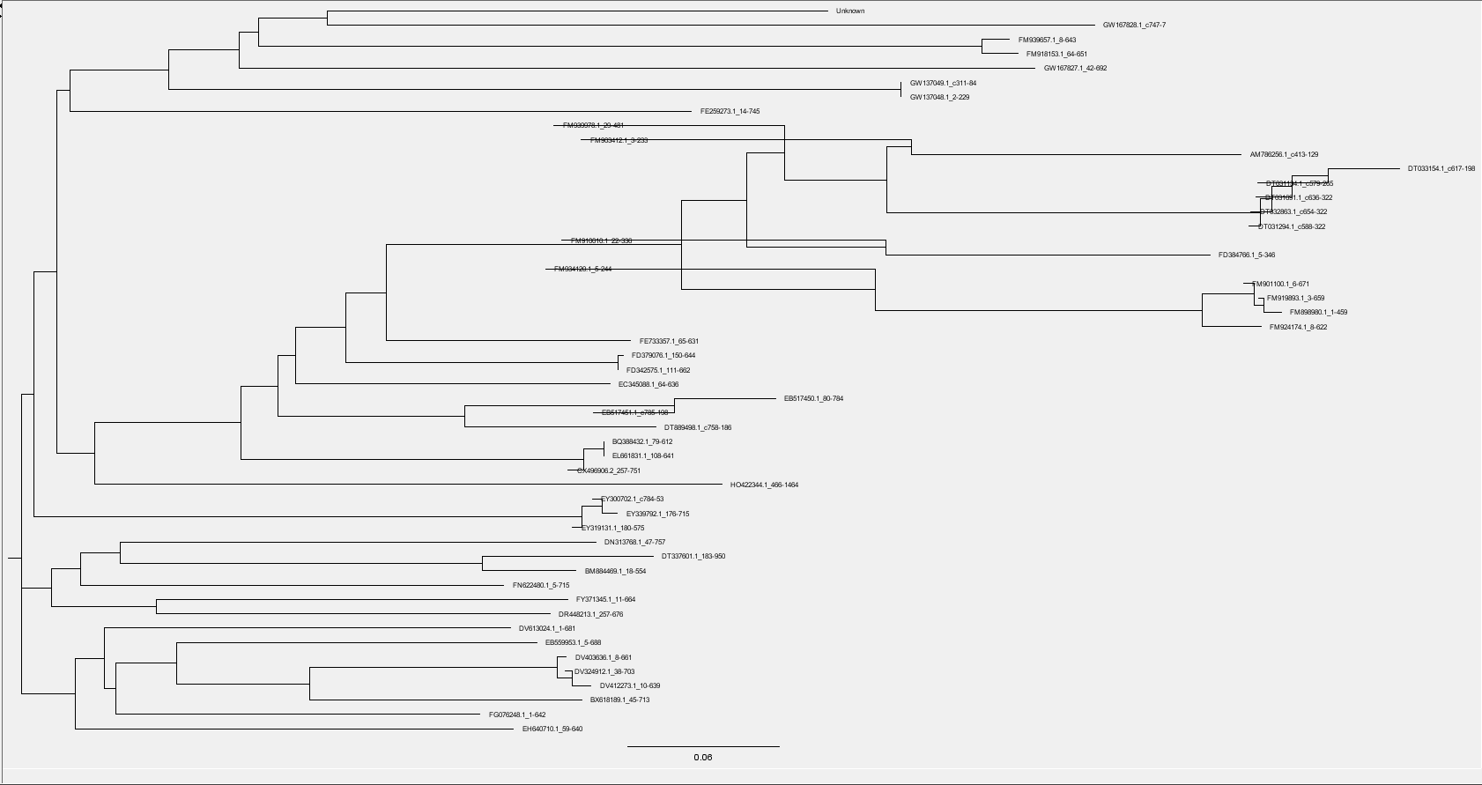

1. Transcriptome Shotgun Assembly-

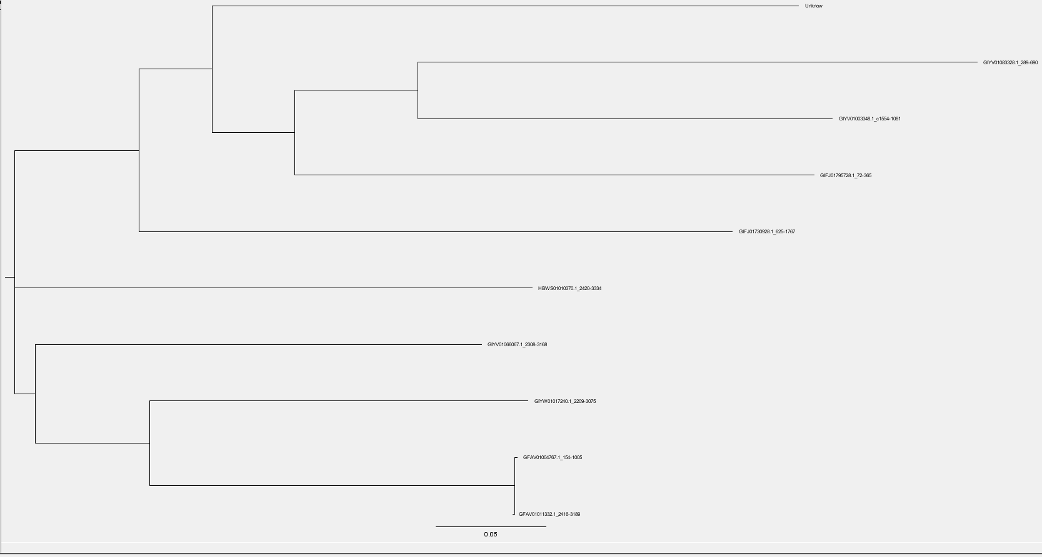

1. Patent Sequences Database-

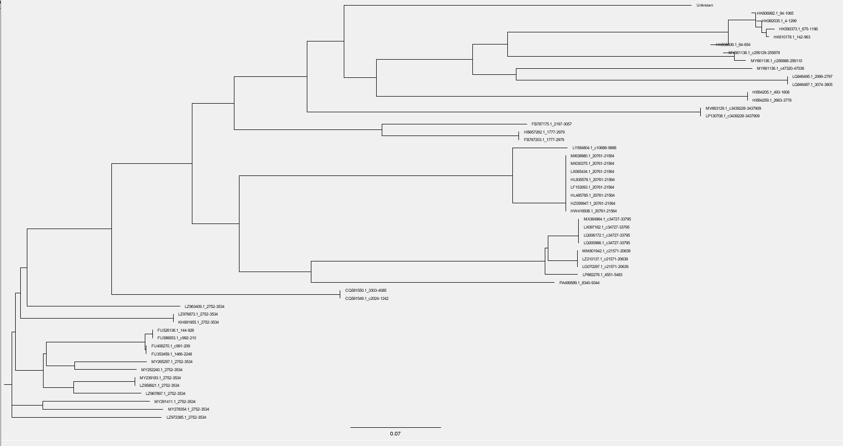

1. Human RefSeq Gene Database-

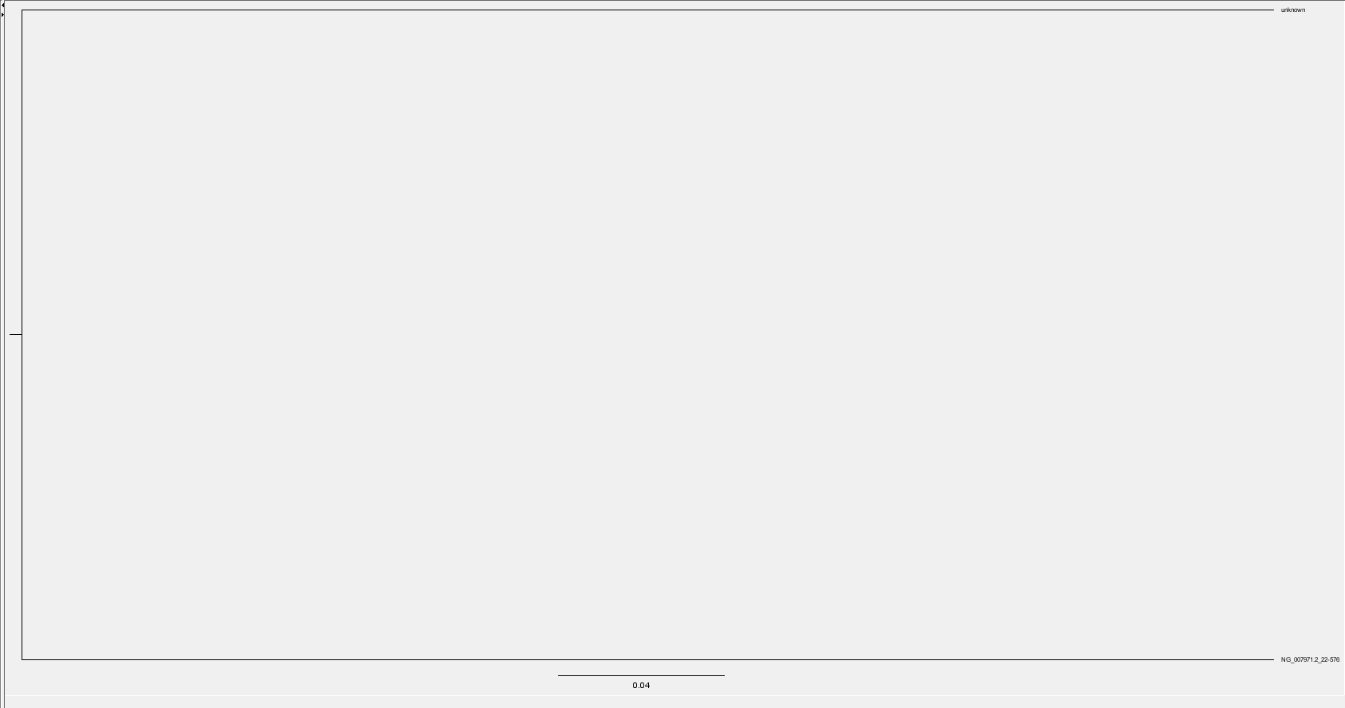

1. Sequence Tagged Sites

